

**DEPARTMENT OF ELECTRONICS AND INSTRUMENTATION ENGINEERING**

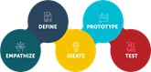

# DESIGN THINKING LAB(EI247DL)

**LOW COST BIKE ACCIDENT DETECTION & ALERTING DEVICE**

**DTL REPORT**

### Submitted By:



Chandana 1RV22EI014

Medha K S 1RV22EI032

Shubham R K 1RV22EI054

Varun S 1RV22EI060

**Under the Guidance of:** Dr. Kendaganna Swamy S. Assistant Professor

##### In Partial fulfilment for the Design Thinking Lab 2023 – 2024

**RV College of Engineering®, Bengaluru** (*Autonomous institution affiliated to VTU, Belagavi)* **Department of Electronics and Instrumentation Engineering**.

**CERTIFICATE**

Certified that the design thinking (EI247DL) work titled “**BIKE ACCIDENT DETECTION & ALERTING DEVICE**” is carried out by Mr/Ms. **Chandana (1RV22EI014), Medha K S (1RV22EI032), Shubham R K (1RV22EI054), Varun S**

**(1RV22EI060)** who are

Bonafede students of RV College of Engineering, Bengaluru, in partial fulfilment of the requirements for the degree of **Bachelor of Engineering** in **Electronics And Instrumentation** of the Visvesvaraya Technological University, Belagavi during the year 2020- 2021. It is certified that all corrections/suggestions indicated for the Internal Assessment have been incorporated in the DTL report deposited in the departmental library.

|  |  |  |
| --- | --- | --- |
| **Marks (50)** | | |
| **Name of the Student** | **USN** | **Obtained Marks** |
| Chandana | 1RV22EI014 |  |
| Medha KS | 1RV22EI032 |  |
| Shubham R K | 1RV22EI054 |  |
| Varun S | 1RV22EI060 |  |

Signature of Mentor Signature of HOD

Dr Kendaganna Swamy



**Name of the Examiners**

1.

2.

##### External Examiners

Dr Renu Madhavi C.H. Signature with date

**TABLE OF CONTENTS**



|  |  |  |
| --- | --- | --- |
| **Sl. No** | **Content** | **Page No** |
| i. | Certificate |  |
| ii. | Design Thinking Lab Rubrics |  |
| 1 | Different perspectives Bike Accident Detection & Alerting Device | 1 |
| 2 | Modern technologies in Bike Accident Detection | 5 |
| 3 | Optimization and soft computing models | 9 |
| 4 | Emerging trends in bike accident detection and alerting system | 12 |
| 5 | Design Thinking Lab Process | 14 |
| 5.1 | Empathy | 16 |
| 5.2 | Survey Outcome | 28 |
| 5.3 | Target Audience | 31 |
| 5.4 | Insights | 33 |
| 5.5 | Key features of the survey and the project | 34 |
| 5.6 | Define | 35 |
| 5.7 | Ideation | 35 |
| 5.8 | Prototype | 37 |
| 5.9 | Components | 38 |
| 6.0 | Working of the model | 42 |
| 6.1 | Model of Low Cost Bike Accident Detection & Alerting Device | 43 |
| 6.2 | Cost Estimation | 44 |
| 6.3 | Conclusion | 44 |
| 7 | Weekly Report | - |
| 8 | Mini Report | - |

**ii. Design Thinking Lab Rubrics (EI247DL)**



#### LEVEL 1 (0-1) LEVEL 2(2-4) LEVEL 3 (5-7) LEVEL 4(8-10)

|  |  |  |  |  |  |
| --- | --- | --- | --- | --- | --- |
| **Empathy** | **Goal** | Understanding that other People experience thinks differently | Discover non-  obvious insights | Discover deeper human- centred insights | Discover a full spectrum human centred insight  (individual/gr oup) |
| **Define** | **Skill Level** | Little experience/c omfort eliciting info from others unlike themselves | Ability to develop diverse approach. Some experience eliciting info from others | Ability to understand perspective and experiences from others | Ability to understand others and the system/process in which they operate and  ability to think like others |
| **Ideate**  **Prototype** | **Goal** | Pick one insight/proble m out of many in a very guided statement | Understand multiple insights and needs and synthesize into a single problem statement with guidance | Develop multiple deep insights and synthesize into a single problem statement with little  or no  guidance | Develop multiple complex problem statements with no guidance |
| **Test** | **Skill Level** | Ability to prioritize based on perceived importance of any insight/problem | Ability to synthesize information and prioritize insights based on perceived needs | Ability to synthesize info based on needs and insights originating from multiple  non obvious internal and external sources | Ability to understand and synthesize deep insights based on complete system |
|  |  |  |  | Develop |  |
|  | To be able to | To develop over | multiple | Use multiple |
| **Goal** | come up with lots of ideas | 20 ideas off a single well- | HMWs,  generate a | techniques for ideation for a |
|  | and defer | crafted HMW | spectrum of | single insight |
|  | judgement |  | ideas from the | and repeat |
|  |  |  | HMWs and |  |
|  |  |  | narrow to a |  |
|  |  |  | few |  |
|  |  |  | actionable |  |
|  |  |  | ideas |  |
|  |  |  |  | Ability to lead | Ability to use multiple techniques to inspire a complete range of ideas. |
| **Skill** | Ability to | Ability to | a brainstorm |
| **Level** | generate and | build of | through a |
|  | record ideas | others’ ideas | spectrum of |
|  | with others | and develop | ideas |
|  |  | wild ideas | from low hanging to wild |

|  |  |  |  |  |  |
| --- | --- | --- | --- | --- | --- |
|  | **Goal** | Create a representation of your idea that someone else can understand | Create a representation of an idea that can be evaluated by others | Create a representatio n that allows one to evaluate specific features of a given idea and develop multiple iterations | Create multiple representations that allow you to evaluate specific features from multiple perspectives and develop multiple iterations |
| **Skill Level** | Ability to make a physical or visual representatio n of an idea | Ability to create a physical or visual representation of an idea that can be evaluated and improved | Ability to identify variables of an idea that needs to be evaluated and iterate off feedback | Ability to create more complex prototype addressing multiple approaches to solving a  problem. |
| **Goal** | To try or show a prototype to see how well it works | To try or show a prototype and efficiently solicit feedback | To create a testing scenario to specific feature and design clear team roles such as presenter,  notetaker, observer. | Real world testing with a range of users and scenarios that address the needs and perspectives of  the complete system. |
| **Skill Level** | The ability to use a prototype to determine how well and idea works | Ability to set up an effective prototype test, solicit feedback, and organize feedback received into actionable results | Ability to solicit feedback about specific features, construct a representative testing situation and capture results to inform future iterations | Ability to identify best situations in the real world for testing and test with multiple representative populations and capture complex results to inform future iterations |

1. **DIFFERENT PERSPECTIVES AND BUILDING BLOCKS OF BIKE ACCIDENT DETECTION & ALERTING DEVICE**

##### The Perspectives on Motorcycle Accident Detection and Alerting System

* + 1. **Accident Rates and Response Time**

Motorcycle accidents have become a growing public safety issue worldwide, particularly in countries like India, where the number of two-wheelers on the road is significantly higher than in many other nations. The high rates of motorcycle accidents can be attributed to several factors, including dense traffic, poor road conditions, and reckless driving behaviour. However, one of the critical factors leading to fatalities is the delayed response time following accidents. In many cases, especially in rural or less populated areas, accidents go unnoticed for long periods, leaving the injured without timely medical attention. Without immediate detection and alerting systems, accident victims often succumb to injuries that might otherwise have been treatable. This underscores the urgent need for low-cost, effective motorcycle accident detection systems that can alert emergency services instantly, reducing the time between the accident and the arrival of medical assistance.

##### The Dynamics of Traffic and Motorcycle Accidents

The dynamics of motorcycle accidents are heavily influenced by the constantly changing nature of urban and rural traffic. In densely populated urban areas, motorcyclists face risks from vehicular congestion, narrow roads, and frequent intersections, making accidents more likely. In contrast, rural areas and highways present a different set of challenges. Long stretches of roads with limited visibility, coupled with speeding vehicles, increase the severity of accidents. Furthermore, motorcyclists, due to their exposure and lack of protective barriers, are much more vulnerable to fatal injuries compared to other motorists. Therefore, the need for a reliable detection system becomes even more critical in these environments. Such systems must be capable of adjusting to different traffic patterns and environments, whether in crowded city streets or desolate highways, ensuring that help is summoned in time regardless of the location.

##### Motorcycle Accident Detection Systems

The current market for motorcycle accident detection systems is primarily dominated by high- end solutions that often include expensive hardware and complex software configurations. While these systems offer excellent accuracy and real-time data transmission, their cost makes

them inaccessible to a large portion of motorcyclists, especially in developing countries like India, where affordability is a key concern. There is an urgent need for low-cost alternatives that can still provide reliable accident detection without the prohibitive costs. This can be achieved by leveraging simple yet effective technologies such as accelerometers, gyroscopes, and GPS modules, which are now widely available and relatively inexpensive. Integrating these components into a robust system that can detect sudden impacts, abnormal movements, or falls, and automatically send alerts to emergency services, could help prevent many fatalities that result from delayed response times.

##### Maintenance and Reliability of Accident Detection Systems

While developing low-cost accident detection systems is crucial, ensuring their maintenance and long-term reliability is equally important. Like any other electronic device, these systems are prone to wear and tear, particularly when exposed to harsh environmental conditions such as extreme heat, rain, or dust, which are common in many parts of India. Additionally, factors such as battery life, sensor calibration, and connectivity issues could affect the system's performance over time. Regular maintenance and timely updates are necessary to ensure that the system remains effective and responsive. Implementing user-friendly mechanisms for system checks and maintenance could increase the longevity of these devices, ensuring that motorcyclists continue to benefit from real-time accident detection over an extended period. The cost of maintaining these systems should also be minimized to keep them accessible for the average rider.

##### Alerting and Emergency Response

The effectiveness of an accident detection system lies not only in detecting the accident but also in its ability to send out immediate alerts that can facilitate a quick response. In India, emergency response services are often constrained by traffic, geographical limitations, and resource shortages. As a result, the time between an accident and the arrival of emergency personnel can be critical. A well-designed detection system should be equipped with robust communication features, such as mobile network integration or satellite communication, to ensure that alerts can be sent even in areas with limited connectivity. Furthermore, providing detailed information, including the exact location and severity of the accident, to emergency services can expedite the response process. By streamlining communication between the

accident site and responders, these systems can help save lives by ensuring that aid arrives as quickly as possible.

##### Motorcycle Accident Response Issues in India

* + 1. **Accident Near Tiruchi Central Bus Stand**

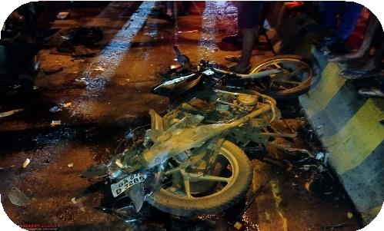

*Figure 1: Motorbike accident*

In a tragic incident that occurred near the Tiruchi Central Bus Stand in Tamil Nadu, a motorcyclist lost his life due to delayed medical assistance. *Figure 1* captures the vehicle’s condition at the accident scene, highlighting the extent of damage to the bike. The victim had been involved in a severe collision during peak traffic hours and

was left lying on the road for nearly an hour before anyone responded. The congested area and chaotic traffic patterns contributed to the delay in spotting the accident. The absence of a reliable accident detection and alerting system meant that bystanders were unaware of the severity of the situation. Had there been a low-cost accident detection system installed on the victim's motorcycle, emergency services could have been alerted instantly, potentially saving the victim's life. This incident underscores the importance of such systems in high-traffic urban areas where accidents can go unnoticed for extended periods.

##### Accidents in Rural Areas

In the rural parts of India, poor road infrastructure, combined with a lack of street lighting, has led to numerous motorcycle accidents, many of which result in fatalities due to delayed emergency responses. In one instance, a motorcyclist collided with a large pothole on a poorly maintained road late at night, suffering severe injuries. Unfortunately, by the time help arrived, it was too late. The isolated location and the absence of nearby witnesses meant that no one noticed the accident for several hours. A low-cost accident detection system could have sent out immediate alerts, significantly reducing the time taken for medical assistance to reach the victim. Such systems are especially crucial in rural areas, where accidents often occur far from help, and rapid response times are critical in preventing fatalities.

##### Highway Accidents near Chennai

*Figure 2: Bike collision at Chennai highways*

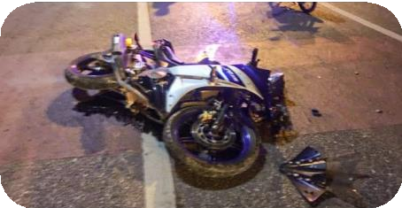

High-speed motorcycle accidents on the highways near Chennai have claimed several lives due to delayed responses. In one particular incident, a motorcyclist was involved in a high-speed collision on the Chennai-Trichy highway, and the accident went unnoticed for over an hour. *Figure 2* documents the motorbike at the accident site. The

desolate stretch of the highway, coupled with the lack of immediate detection, contributed to the victim's untimely death. Had a low-cost accident detection system been in place, it could have automatically triggered an alert to nearby medical facilities, enabling them to respond faster. This highlights the need for such systems, particularly on highways where accidents may not be quickly detected due to low traffic volumes or the absence of nearby witnesses.

##### The Socio-Cultural Perspectives on Bike Accident Detection & Alerting Devices

* + 1. **User Acceptance and Behaviour**

The success of accident detection devices largely depends on user acceptance. Riders must be willing to carry or install such devices and trust their functionality. Some may perceive these devices as unnecessary or intrusive, especially if false alerts occur frequently. Educating users on the benefits and demonstrating reliability is key to increasing adoption. Cultural attitudes toward technology and safety can also influence how these devices are perceived and used.

##### Privacy Concerns

Accident detection devices often track location and other personal data, raising privacy concerns. Users may be hesitant to use these devices if they feel their movements are being monitored without sufficient safeguards. To address this, manufacturers must implement strict data privacy policies, ensure secure data transmission, and offer transparency on how data is used. Giving users control over their data, such as the ability to opt-in or out of certain features, can also help alleviate concerns.

##### Impact on Emergency Response Systems

Widespread use of accident detection devices could place additional demands on emergency response systems. If not managed properly, false alarms could strain resources and lead to slower response times for genuine emergencies. Collaboration between device manufacturers,

emergency services, and policymakers is essential to develop protocols that prioritize serious incidents and manage false positives effectively.

##### The Economic Perspectives on Bike Accident Detection & Alerting Devices

* + 1. **Cost of Development and Implementation**

The development of reliable accident detection devices involves significant research and investment, especially in sensor technology, data processing, and communication systems. These costs can impact the final price of the device, potentially making it less accessible to the average consumer. Manufacturers must find a balance between cost and functionality to produce devices that are affordable while maintaining high performance. Additionally, economies of scale could reduce costs over time as adoption increases.

##### Market Demand and Business Opportunities

The market for accident detection devices is influenced by the increasing awareness of road safety, government regulations, and the growing number of cyclists. These factors create business opportunities for manufacturers, tech companies, and service providers. Companies that can innovate and offer superior products may capture significant market share. Furthermore, the potential for integrating these devices with insurance products, offering discounts or incentives to users, presents an additional revenue stream.

##### Insurance Implications

Accident detection devices can play a role in reducing insurance claims by providing accurate data on the circumstances of an accident. This data can help in assessing liability, reducing fraud, and expediting claims processing. Insurers may offer lower premiums to cyclists who use these devices, as they can help in preventing accidents or minimizing their impact. However, the initial investment cost for users might be a barrier, requiring insurers to consider subsidizing the devices or providing them as part of their policies.

#### MODERN TECHNOLOGIES AND SYSTEMS IN MOTORCYCLE

**ACCIDENT DETECTION**

The implementation of advanced technologies in the realm of motorcycle accident detection has significantly evolved in recent years. The focus has shifted from simple passive systems, like helmets and protective gear, to sophisticated active systems that aim to predict, detect, and respond to accidents in real time. The development of intelligent systems integrated with the

Internet of Things (IoT), sensors, and machine learning algorithms has created a new frontier in accident detection and alerting, offering a more proactive approach to road safety.

##### Traditional Methods of Accident Detection: Limitations and Challenges

Before the advent of modern technology, motorcycle accidents were primarily detected through traditional methods that relied heavily on human intervention. Witnesses, passersby, or emergency services personnel were the primary means of identifying and reporting accidents. These methods were often time-consuming and prone to inaccuracies. Witnesses might provide incomplete or misleading information, leading to delays in emergency response. Additionally, in remote areas or during off-peak hours, it might take considerable time for someone to discover an accident.

The limitations of traditional methods were particularly evident in cases where accidents occurred in isolated areas or during times of low traffic. In such situations, it might take hours or even days before an accident was discovered, significantly reducing the chances of timely medical intervention. Furthermore, the accuracy of traditional methods was often questionable, as witnesses might be unable to provide a clear and accurate account of the accident due to factors such as shock, confusion, or limited visibility.

The reliance on traditional methods also hindered the ability to gather comprehensive data on motorcycle accidents. Without reliable and consistent reporting, it was difficult to accurately assess the frequency, causes, and consequences of these accidents. This lack of data made it challenging to develop effective prevention strategies and allocate resources appropriately.

##### Accident Detection Algorithms

The effectiveness of these systems hinges on the accuracy of the detection algorithms, which must differentiate between normal riding behaviour and crash scenarios. The algorithms are designed to process data from the accelerometer and gyroscope in real time. Sudden, sharp changes in acceleration or angular velocity are flagged by the system as potential accidents. For example, if the motorcycle rapidly decelerates or tilts beyond a specific angle without subsequent correction, the system triggers an alert.

Machine learning algorithms have been increasingly adopted to improve the accuracy of accident detection. These algorithms can be trained using datasets of real-life riding scenarios, including accidents and normal driving conditions. Over time, the system learns to identify

patterns that correlate with accidents, reducing the number of false positives. This ability to continuously adapt and improve makes machine learning an essential component in modern accident detection systems.

##### IoT Integration and Connectivity

One of the most significant advancements in motorcycle accident detection systems is the integration with IoT platforms. IoT allows the system to connect to a broader network of devices, enabling data sharing across multiple platforms. This connectivity enhances the functionality of the detection system, allowing for the immediate transmission of accident data to relevant stakeholders. For instance, an accident detection system connected via IoT can automatically notify local hospitals, police, or even nearby drivers of an accident, ensuring swift assistance.

Moreover, IoT integration allows for the system to store historical data related to accidents and riding behaviour. This data can be utilized for analysis, helping manufacturers and researchers identify trends in accident causes and design more effective safety measures. Additionally, insurers may use this data to assess risk more accurately, potentially leading to personalized insurance plans based on individual riding habits.

##### Advanced Rider Assistance Systems (ARAS)

Advanced Rider Assistance Systems (ARAS), which are increasingly important for improving driving safety and behaviour. They focus on two primary approaches: one based on inertial measurement units (IMUs) and another leveraging video-based technique. Roll angle estimation is critical for stability in powered two-wheelers, as large roll angles can cause significant variations in recorded images and vehicle dynamics.

The IMU-based methods involve estimating the motorcycle’s orientation through sensory inputs like velocity, acceleration, roll rate, and yaw rate. The paper discusses two methods: a combined filter method and a Kalman filter method. The Kalman filter method, which integrates the roll rate and roll angle over time, outperforms the combined filter method in accuracy, providing robust estimation results even during dynamic manoeuvres. The IMU- based Kalman filter estimation consistently showed high precision with an average error of approximately two degrees across various driving scenarios.

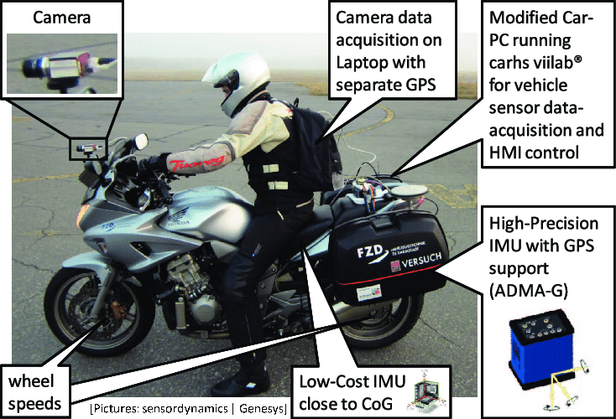*Figure 3: Advanced Rider Assistance System*

In parallel, the video-based approach learns the roll angle by analysing the orientation distribution of image gradients recorded by a camera mounted on the motorcycle. *Figure 3* showcases the various features, providing clear description of the ARAS system.

While initial research on synthetic data demonstrated promising results, this paper advances the work by applying it to real-world data captured during experimental tests. Significant enhancements were made to the original method, including the introduction of evolutionary optimization using the Covariance Matrix Adaptation Evolution Strategy (CMA-ES), leading to notable improvements in estimation accuracy. The revised video-based method demonstrated similar performance to the Kalman filter, with a comparable error margin of about two degrees.

##### Helmet-Based Motorcycle Accident Detection System

Helmets play a crucial role in preventing head injuries and fatalities in motorcycle accidents. However, even with helmets in place, accidents can occur, and timely intervention is essential. Helmet-based accident detection systems leverage the ubiquitous nature of helmets to provide a proactive approach to safety. These systems typically incorporate various sensors, including accelerometers, gyroscopes, impact sensors, and heart rate monitors. These sensors continuously monitor the rider's movements and environment. When the sensors detect a sudden impact or change in motion that exceeds predefined thresholds, the system determines that an accident has occurred.

To communicate this information to emergency services or designated contacts, helmet-based accident detection systems utilize communication modules such as GPS and cellular connectivity. This enables the system to transmit the rider's location and other relevant data in real-time. Additionally, some systems may include features such as automatic emergency calls, crash data recording, and integration with other safety technologies. Helmet-based accident

detection systems offer several benefits. By providing real-time accident alerts, these systems can significantly reduce the time it takes for emergency services to reach the scene, potentially saving lives. The sensors used in these systems can accurately detect accidents, even in situations where human witnesses may be limited or absent.

Moreover, helmet-based accident detection systems can help to promote safer riding habits by providing riders with feedback on their behaviour and encouraging them to adopt defensive driving techniques. Additionally, these systems can collect valuable data on motorcycle accidents, which can be used to identify trends, improve road infrastructure, and develop more effective safety measures. While helmet-based accident detection systems offer significant potential, there are still challenges to be addressed. These include ensuring sufficient battery life to support the system's functionality, overcoming the initial cost of equipping helmets with these systems, and protecting the privacy of riders and their data.

#### OPTIMIZATION AND SOFT COMPUTING MODELS

##### Methods of Accident Detection

A bike accident detection system typically integrates various sensors and communication modules to identify accidents and alert relevant parties. The system configuration includes accelerometers, gyroscopes, GPS modules, and GSM modules. The primary methods of accident detection are:

1. **Accelerometer-Based Detection-** An accelerometer measures changes in velocity and direction, detecting sudden deceleration or impact. When combined with algorithms, it helps in identifying accidents by analysing abrupt changes in motion. This method is effective for detecting high-impact crashes but may be sensitive to sudden braking or minor bumps.
2. **Gyroscope-Based Detection-** A gyroscope measures rotational movement, detecting significant changes in orientation that might indicate a fall or crash. This method helps differentiate between normal riding maneuvers and accident scenarios, providing additional context for more accurate detection.
3. **GPS-Based Detection-** The GPS module tracks the bike's location and movement, providing data on speed and position. Sudden, drastic changes in location or speed,

combined with accelerometer and gyroscope data, can help identify potential accidents and verify their severity.

##### Alerting Methods

The alerting methods in bike accident detection systems ensure timely notification to emergency contacts or services.

Some common alerting methods include:

1. **GSM Module (SIM 800L)-** The GSM module enables the system to send SMS alerts or make phone calls when an accident is detected. The SIM 800L module is integrated into the system to facilitate real-time communication, ensuring that alerts reach emergency contacts promptly.
2. **Mobile App Notifications**- Alerts can be sent through a mobile app, providing real- time updates and GPS coordinates to emergency contacts or services. This method offers a more user-friendly interface and additional features like live tracking and incident reporting.
3. **Automated Emergency Calls**- The system can automatically place emergency calls to predefined numbers when an accident is detected. This feature ensures immediate human intervention and facilitates quick response from emergency services.
4. **Email Alerts-** The system can send email notifications to family members or emergency contacts, providing detailed information about the accident, including location data and sensor readings.

##### Integration and Optimization

Sensor Fusion Combining data from the accelerometer, gyroscope, and GPS modules using sensor fusion algorithms enhances the accuracy of accident detection. This approach reduces false positives and ensures more reliable performance. Power Management Optimizing power consumption by utilizing low-power modes and efficient battery management extends the device's operational life, making it more practical for everyday use. Cost Optimization Using cost-effective components and open-source software for data processing and communication helps keep the overall system affordable while maintaining functionality and reliability.

##### Testing and Calibration

Field Testing Conducting extensive field tests to calibrate the sensors and algorithms ensures the system accurately detects accidents in real-world scenarios. Algorithm Refinement Continuously refining detection algorithms based on test data helps improve accuracy and reduce false alarms, ensuring the system’s effectiveness in emergency situations. This optimized model provides a comprehensive solution for bike accident detection and

##### Cost Effective IoT model for Bike accident & Alerting device.

This device is a battery-powered, compact, and cost-effective solution for motorcycle safety. It incorporates an accelerometer sensor to detect accidents, a GPS tracking system to pinpoint the location, and a communication system to send SOS alerts to emergency numbers.

When the motorcycle encounters an accident, the accelerometer sensor detects sudden changes in speed and vibrations. If these changes exceed a predefined threshold, the device determines that an accident has occurred. It then acquires the motorcycle's precise location using the GPS module and transmits an SOS message along with the coordinates to the designated emergency number. The device can be powered by a lithium battery, which can be charged using a USB cable or a DC supply of 12V 2A. This flexibility allows for convenient charging options. Designed to be small and lightweight, the device can be easily placed within the motorcycle's seat or frame, making it unobtrusive and convenient for riders.

In addition to accident detection, this device can also be used for live tracking of the motorcycle. The GPS module continuously transmits the motorcycle's location to a designated server or mobile app, enabling riders and owners to monitor their vehicle's whereabouts. By incorporating these features, this low-cost motorcycle accident detection and alerting device offers a valuable safety solution for riders. It provides timely assistance in case of an emergency

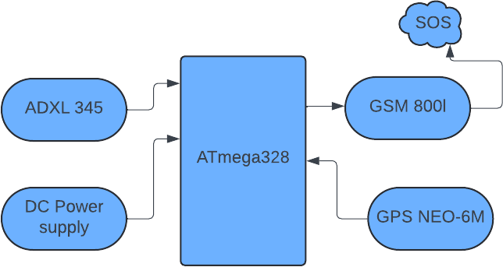

*Figure 4: Block Diagram*

and can also be used for tracking the motorcycle's location, enhancing overall safety and peace

of mind. *Figure 4* illustrates a block diagram which provides an overview of the architecture of the smart bike accident detection and alerting device.

#### EMERGING TRENDS IN BIKE ACCIDENT DETECTION AND ALERTING DEVICE

The increasing number of motorcycle accidents has spurred the development of innovative technologies to enhance safety and provide timely assistance. Bike accident detection and alerting devices have evolved significantly, incorporating advanced sensors, communication technologies, and artificial intelligence to improve their effectiveness.

##### Integration of AI and Machine Learning

* **Enhanced Accident Detection:** AI algorithms can analyse sensor data more accurately, distinguishing between genuine accidents and false positives.
* **Predictive Analytics:** AI can predict potential accident scenarios based on rider behaviour, road conditions, and environmental factors.
* **Adaptive Thresholds:** AI can dynamically adjust the accident detection threshold based on real-time conditions, improving accuracy and reducing false alarms.

##### Advancements in Sensor Technology

* **Multi-Sensor Fusion:** Combining data from multiple sensors, such as accelerometers, gyroscopes, barometers, and magnetometers, provides a more comprehensive understanding of the accident scenario.
* **Wearable Sensors:** Integrating sensors into helmets, jackets, or gloves can capture additional data, such as rider posture and vital signs, for more accurate accident assessment.
* **IoT Integration:** Connecting devices to the Internet of Things (IoT) enables data sharing, remote monitoring, and integration with other safety systems.

##### Enhanced Communication Capabilities

* **Real-time Alerts:** Devices can send immediate alerts to emergency services, family members, or friends, reducing response times.
* **Smart Routing:** AI can determine the most efficient route for emergency services based on traffic conditions and accident severity.
* **Integration with Smart Cities:** Devices can connect to smart city infrastructure, providing real-time information on road conditions and potential hazards.

##### Cloud-Based Solutions

* **Data Storage and Analysis:** Cloud-based platforms can store and analyze large amounts of data, enabling data-driven insights and improvements in accident prevention.
* **Remote Monitoring:** Cloud-based solutions allow for remote monitoring of devices, ensuring proper functioning and timely updates.
* **Machine Learning as a Service:** Leveraging cloud-based machine learning services can accelerate development and reduce costs.

##### Additional Features and Trends

* **Integration with Smart Helmets:** Combining accident detection with smart helmet features, such as head impact monitoring and communication capabilities, can provide a comprehensive safety solution.
* **Predictive Maintenance:** Devices can monitor the health of components and predict maintenance needs, reducing downtime and ensuring optimal performance.
* **Social Impact:** Accident detection devices can contribute to data-driven research and policy development, improving road safety for all.

As technology continues to advance, we can expect to see even more innovative and effective bike accident detection and alerting devices. These emerging trends will play a vital role in enhancing road safety, saving lives, and reducing the impact of motorcycle accidents.

DTL PROCESS

##### Introduction Design Thinking

Design thinking is a human-based approach to innovation that aims to establish creative ideas

and effective business models by focusing on the needs of people. The basic idea behind design thinking is that you apply the approaches and methods of designers to the development of innovations while also engaging in a systematic, fact-based analysis of the feasibility and economic viability of these innovations just like what a researcher does. The shaping and design of material products is just one application area. You can use this approach for all areas in life and business. Maybe you want to enhance your customer service, introduce new ways of executing your business processes, or change the corporate culture. Then you are dealing with many-layered issues. When you have no simple solutions, design thinking helps you find an innovative solution. There are some things to keep in mind for the success of design thinking i.e., Free of prejudices about how something works, Free of expectations about what will happen, filled with curiosity to understand things more deeply, Open to a world of possibilities since we do not yet know at the beginning of our “journey” what is possible and what is not, fail early on and often; learn quickly.

##### The need of design thinking

* + - It helps to generate innovative solutions for problems.
    - It also plays role in meeting the customer needs.
    - It provides the modern solutions according to the needs.
    - It is very useful in the current pandemic situation, as we need many solutions for the problems.

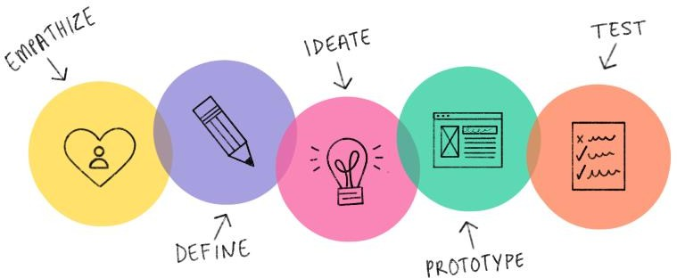

*Figure 5: Design Thinking*

As per *Figure 5*, there are some stages in design thinking process:

#### EMPATHY

Design thinking is a human-centred approach to problem-solving. It prioritizes understanding and empathizing with people's needs and desires. By focusing on people, we can identify problems and develop solutions that truly address their challenges. Our project began with an online survey to gain insights into people's perspectives on the pandemic. We received 107 responses, which we analysed to better understand their concerns and experiences. The following graph visually represents their reactions.

This survey aims to understand the riding habits, safety practices, and experiences of motorcyclists, as well as to gather insights into the perceived effectiveness of current safety measures and potential improvements. The feedback collected will help us develop innovative solutions which aims to enhance safety for motorcyclists by providing real-time alerts and emergency assistance in the event of an accident. Your responses are invaluable in shaping a safer riding environment for everyone.

##### How often you ride motorcycle?

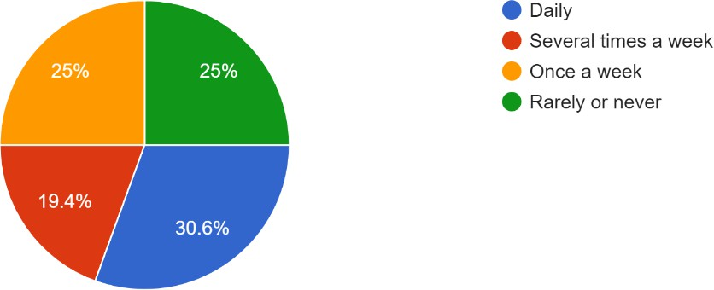

*Figure 6: Survey Question 1*

The majority of respondents ride frequently, with 25% riding daily and 30.6% several times a week. This indicates that the audience is actively engaged with motorcycles, which is relevant for testing accident detection systems. Recognizing the ratio of people using motorcycle as shown in *Figure 6* will allow us to highlight the importance of our bike accident detection and alerting system.

##### What type of motorcycle you ride?

The responses were diverse, with 34.4% riding touring bikes and 31.3% riding dual- sport/adventure bikes. This suggests that the system should cater to different motorcycle types and usage conditions. It is important to notice the different models of bikes as depicted by *Figure 7*, to cater our design accordingly.

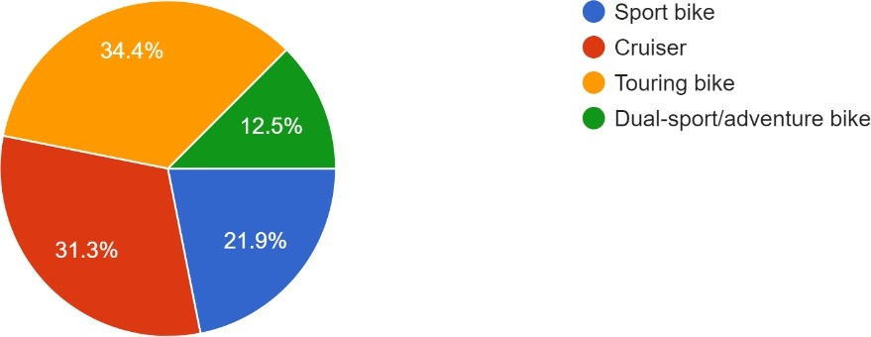

*Figure 7: Survey Question 2*

##### Do you wear helmet while riding?

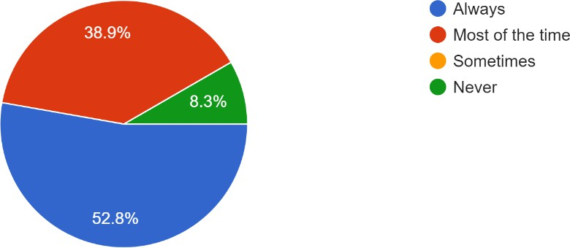

*Fig 8: Survey Question 3*

Helmet usage is high, with 52.8% always wearing a helmet and 38.9% wearing one most of the time. Safety-conscious riders might be more open to using a detection system. Wearing helmet has always been a habit that isn’t followed strictly, but surprisingly many do wear helmets on a daily basis as per *Figure 8.*

##### Have you ever been involved in a motorcycle accident?

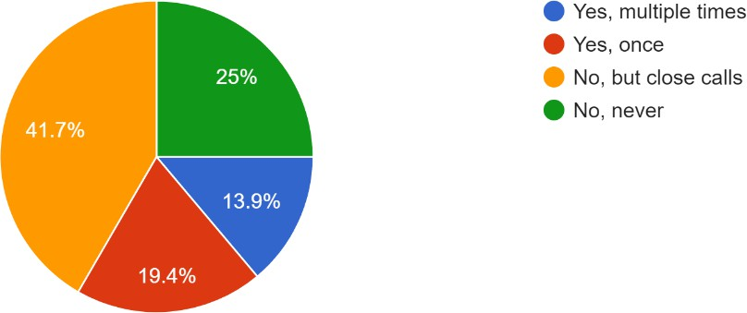

*Fig 9: Survey Question 4*

This question pertains to one of our main concerns. Referring to the previous question, even with a greater percentage of riders wearing helmet, as shown in *Figure 9*, many have been involved in accidents. 41.7% had close calls but no accidents, while 25% had been involved in an accident once. The prevalence of close calls emphasizes the need for preventive measures like accident detection.

##### If yes, how severe was the accident?

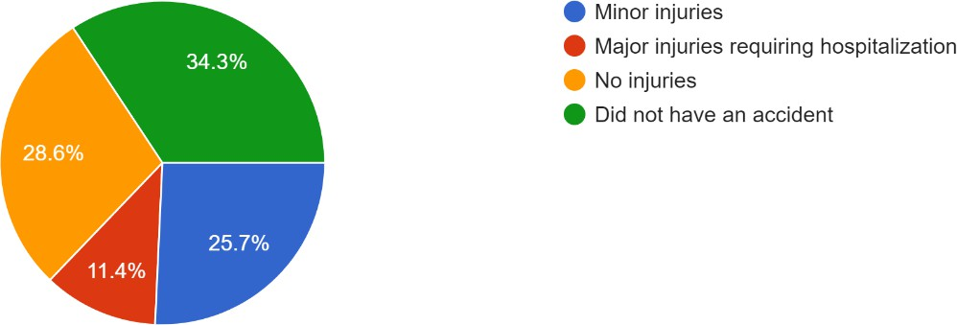

*Fig 10: Survey Question 5*

This question helps assess the severity of the accident, guiding emergency response, refining accident detection algorithms, and providing critical data for insurance and legal purposes. *Figure 10* helps us ensures the system responds appropriately based on the seriousness of the accident. Of those who had accidents, 34.3% reported minor injuries, while 28.6% had major injuries requiring hospitalization. This highlights the importance of quick response times in the system.

##### Where did the accident occur?

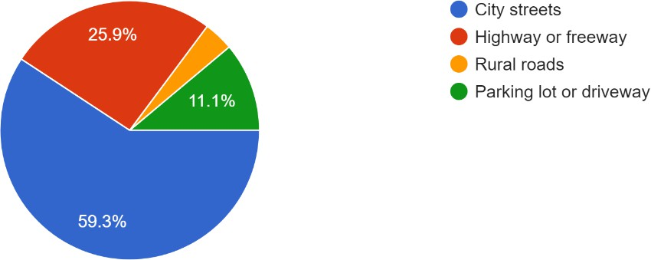

*Fig 11: Survey Question 6*

This question pinpoints the accident location, enabling quick emergency response and providing context for analyzing environmental or road factors. It also aids in refining GPS- based safety features in accident detection systems for better accuracy and assistance. Response in *Figure 11* shows us that most accidents (59.3%) occurred on city streets, followed by highways (25.9%). This indicates that urban environments might be a primary focus for accident detection.

##### Were there any contributing factors to the accident?

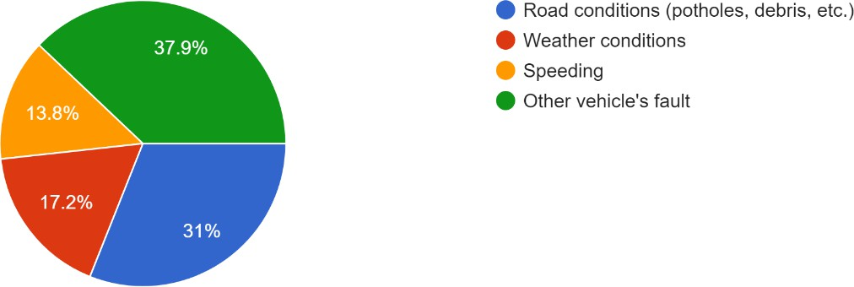

*Fig 12: Survey Question 7*

This question identifies the following factors: road conditions, rider behaviour, weather condition or speeding that contributed to the accident. Understanding these helps improve accident prevention and refine safety systems for better decision-making and accountability. As seen in *Figure 12*, road conditions like potholes were a major factor (37.9%), followed by

the fault of another vehicle (31%). The system should consider external factors in detecting accidents.

##### Did the accident involve any other vehicles?

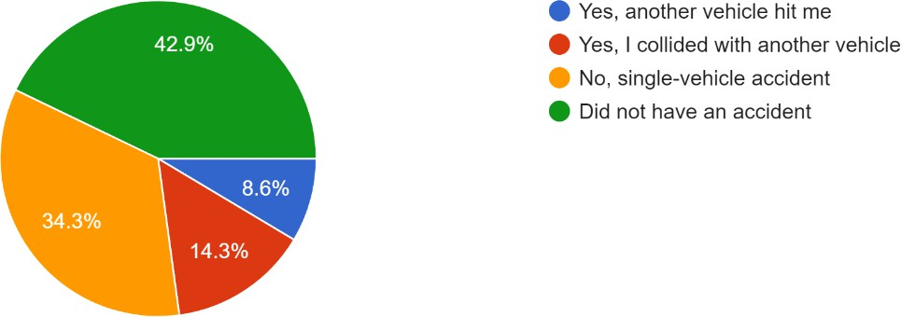

*Fig 13: Survey Question 8*

This question is essential for determining the complexity of the accident. As per *Figure 13*, we considered accidents happened due to another vehicle collision or collision because of the rider himself. This tells us about potential liability, the need for multiple emergency responses, and further investigation. It helps refine accident detection systems to better assess multi-vehicle crashes and coordinate appropriate actions.42.9% of accidents were single-vehicle incidents, while 22.9% involved collisions with another vehicle. This suggests that the system should account for both types of accidents.

##### Were you aware of motorcycle safety rules and regulations at the time of the accident?

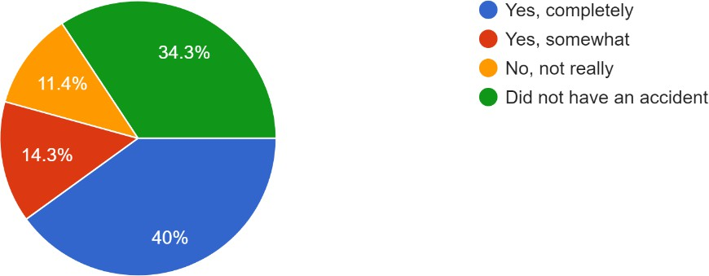

*Fig 14: Survey Question 9*

34.3% were completely aware of the rules, though 40% did not have an accident. This shows that even aware riders experience accidents, highlighting the system's need to detect and alert irrespective of rider knowledge. *Figure 14* gauges the rider's familiarity with local safety regulations, such as helmet laws, speed limits, and other important practices. Understanding

whether riders are informed about safety rules can highlight areas where education or enforcement might be lacking, contributing to accident prevention strategies.

##### Did you receive medical assistance following the accident?

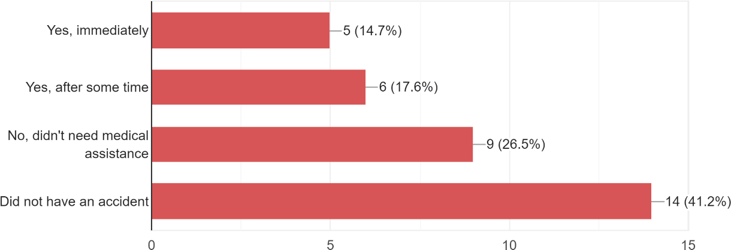

*Fig 15: Survey Question 10*

*Figure 15* addresses the rider's ability to access immediate medical care after an accident. It helps assess the effectiveness of emergency services and their availability in the area. If many riders report difficulties in receiving timely help, it may indicate gaps in the healthcare system or response infrastructure. Immediate medical assistance was only received by 26.5%, indicating that timely alerts could be critical for improving outcomes in accidents.

##### How did you or others involved in the accident seek help?

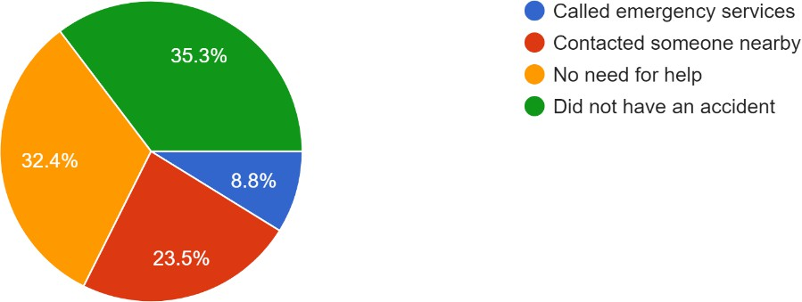

*Fig 16: Survey Question 11*

35.3% contacted someone nearby, but 23.5% didn’t need help. Quick automatic alerts to emergency services could cover those who cannot call for help themselves. *Figure 16* examines the methods used to get help, such as calling emergency services, using a safety app, or relying

on bystanders. The response reveals how well riders know how to seek help and whether current systems (like emergency hotlines or apps) are effective in high-stress situations.

##### How long did it take for help to arrive after the accident?

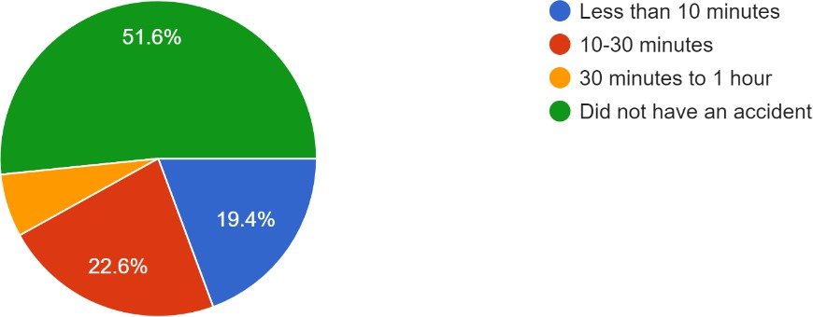

*Fig 17: Survey Question 12*

51.6% reported help arriving in 10-30 minutes. Reducing this response time is a potential benefit of the accident detection system. Response time is critical in reducing the severity of injuries and improving outcomes after an accident. This question helps assess the efficiency of emergency services and infrastructure. *Figure 17* indicates the need for better dispatch systems or quicker emergency access.

##### Did witnesses to the accident provide any assistance or support?

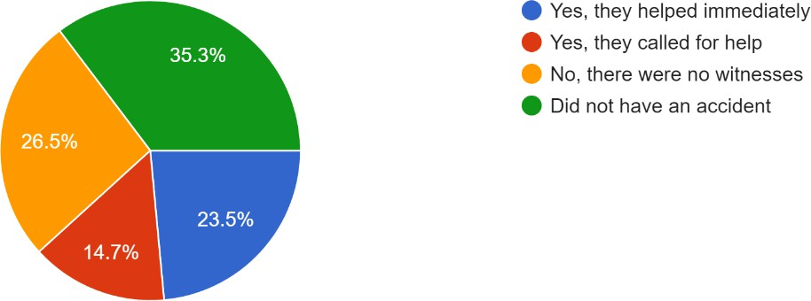

*Fig 18: Survey Question 13*

Witnesses were present and helped immediately in 23.5% of cases. The detection system could be useful in accidents where no witnesses are present. Response time is critical in reducing the severity of injuries and improving outcomes after an accident. *Figure 18* helps assess the

efficiency of emergency services and infrastructure. Longer response times may indicate the need for better dispatch systems or quicker emergency access.

##### Have you ever used a motorcycle accident detection or safety app before?

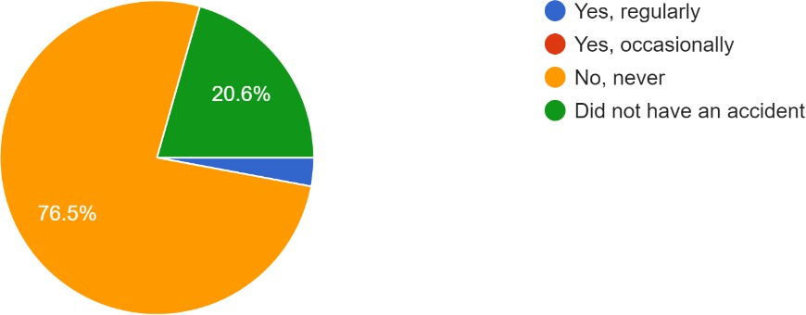

*Fig 19: Survey Question 14*

*Figure 19* assesses the rider’s previous experience with safety technologies like accident detection systems. If many have used such apps, it can point to growing awareness and demand for technology-driven safety solutions. For those unfamiliar, this highlights an opportunity for broader adoption and education on these tools. 5% have never used an accident detection app, indicating the potential for this system to reach a largely untapped market.

##### How effective do you find current motorcycle safety measures in your area?

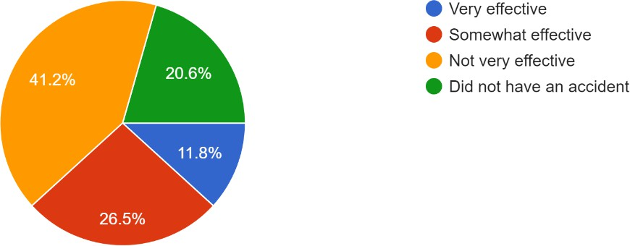

*Fig 20: Survey Question 15*

41.2% rated safety measures as not very effective, pointing to the need for improvements that your system could help address. This question seeks opinions on the existing safety protocols, such as road conditions and traffic management. *Figure 20* is the feedback that can provide

insight into whether current measures are sufficient or if there are areas that need improvement, like better lighting and speed control

##### What improvements could be made to motorcycle safety infrastructure in your community?

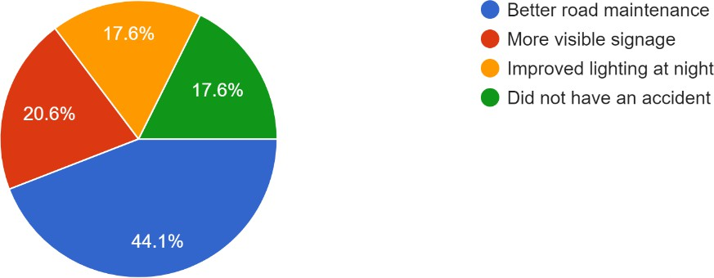

*Fig 21: Survey Question 16*

This asks riders for specific suggestions on how to enhance local safety conditions, such as building better roads and increasing rider education. *Figure 21* gathers direct feedback from riders ensures that proposed changes address real concerns and lead to more practical solutions. Better road maintenance (20.6%) and improved lighting (17.6%) were highlighted. These improvements could complement your system in preventing accidents.

##### Do you think motorcycle accident detection systems would be beneficial?

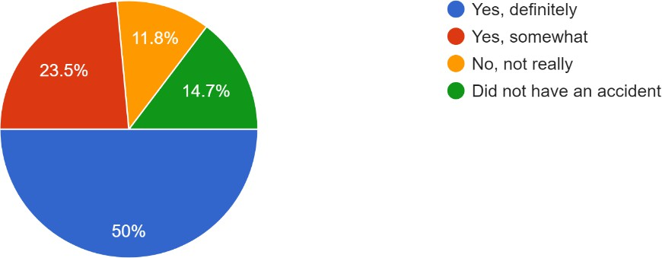

*Fig 22: Survey Question 17*

Here, we are measuring the perceived usefulness of accident detection systems. If riders believe these systems can help, it indicates a strong market and need for these technologies. If they don’t see the benefit, further education on the systems' capabilities may be necessary. *Figure*

*22* shows us that, 50% believe they would definitely be beneficial, indicating strong support for such technology**.**

##### How likely are you to use a motorcycle accident detection system if it were available?

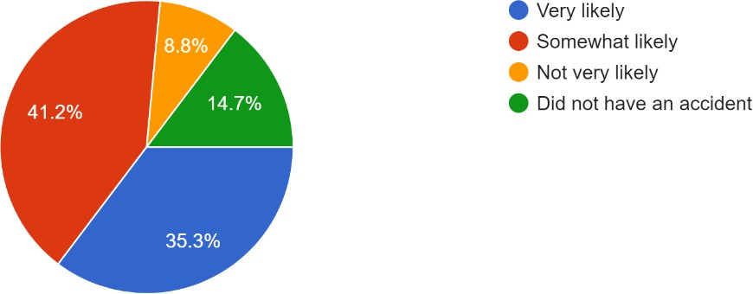

*Fig 23: Survey Question 18*

This question assesses a rider's willingness to adopt new safety technologies. It can reveal potential barriers to adoption, such as cost, skepticism, or lack of awareness. High likelihood points to a ready market, while low likelihood may require more targeted efforts to demonstrate the system's value. As per *figure 23*, 41.2% are very likely to use such a system, showing a high interest in adoption.

##### Would you prefer a motorcycle accident detection system that automatically calls emergency services or one that requires your confirmation?

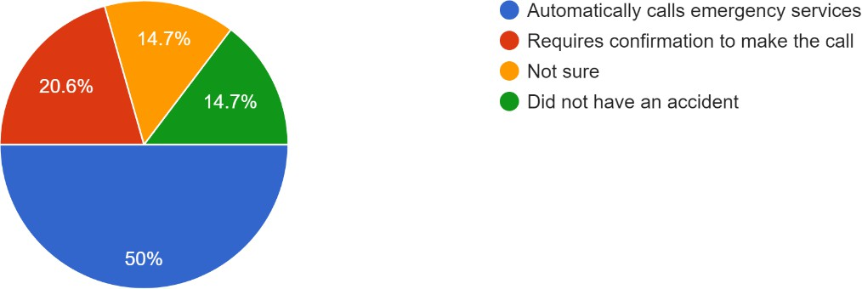

*Fig 24: Survey Question 19*

This evaluates user preferences for automation versus manual control in emergency situations. Riders who prefer automatic systems may prioritize quick response, while those favoring manual confirmation may value avoiding false alarms. Understanding this preference can guide

the design of user-friendly systems. Our survey results 50% were unsure, but 20.6% preferred a system that requires confirmation as represented in *figure 24*. This indicates a need to offer customizable alert options.

##### What features would you consider essential in a motorcycle accident detection system?

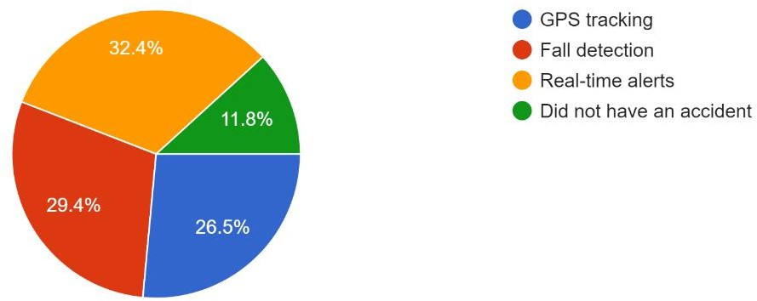

*Fig 25: Survey Question 20*

Survey response *Figure 25* tells GPS tracking and real-time alerts are favoured by 32.4% and 29.4%, respectively. These features should be central to the system’s design. This gathers insight into what riders expect from such systems, whether it's GPS tracking, automatic alerts, real-time location sharing, or impact detection. Their input ensures that developers focus on features that matter most to riders, enhancing adoption and effectiveness.

##### How concerned are you about motorcycle accidents affecting your overall safety while riding?

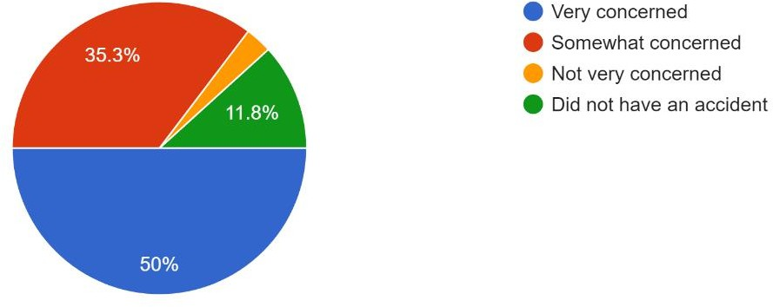

*Fig 26: Survey Question 21*

As per *Figure 26*, 50% were somewhat concerned, and 11.8% were very concerned, highlighting safety as a significant issue among riders. This question measures the rider's perception of risk. If concern is high, there’s a stronger case for implementing or improving

safety measures. Low concern may point to complacency or underestimation of risks, highlighting areas where rider awareness campaigns may be necessary.

##### Do you think motorcycle accidents have increased or decreased in your area in recent years?

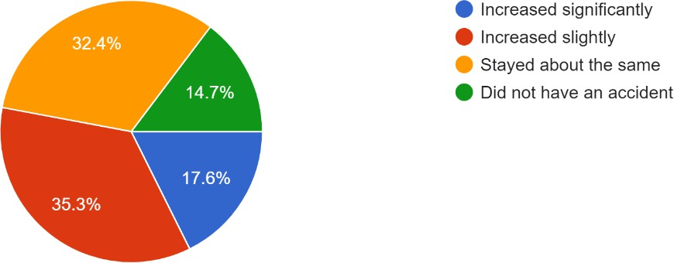

*Fig 27: Survey Question 22*

This provides a sense of local trends in accident rates, from the perspective of the riders. If riders believe accidents are increasing, it may suggest growing dangers, inadequate infrastructure, or higher motorcycle use. If they think accidents are decreasing, it could indicate successful safety initiatives. As per *Figure 27,* 32.4% felt that accident rates had stayed the same, but 17.6% believed they had increased significantly. This suggests ongoing safety risks that the system could help mitigate.

##### Have you ever participated in motorcycle safety training or workshops?

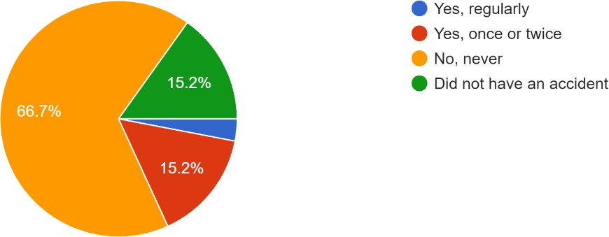

*Fig 28: Survey Question 23*

This question gauges the rider's commitment to safety and education. Participation in safety training often correlates with lower accident rates, as trained riders are more aware of risks and defensive riding techniques. Lack of participation may signal the need for more accessible or

incentivized training programs. As per *Figure 28* shows 66.7% had never participated in safety training, which shows that accident detection systems could serve an even more critical role in enhancing safety for untrained riders.

##### Would you be willing to pay for a motorcycle accident detection system if it could significantly improve your safety?

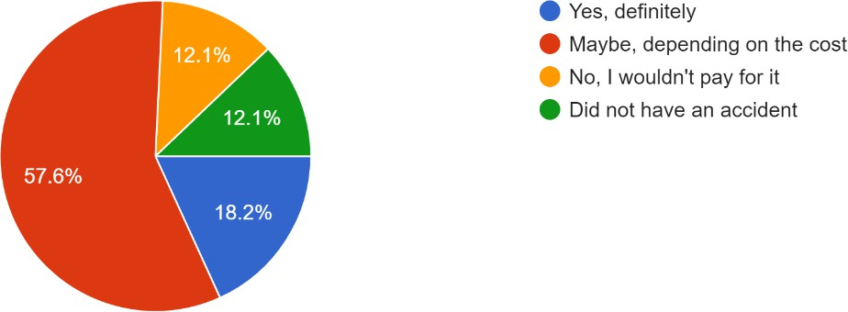

*Fig 29: Survey Question 24*

This measures a rider's readiness to invest in their safety. Positive responses suggest that there is a market for paid systems, while reluctance might indicate price sensitivity or skepticism about the system’s effectiveness. It can also inform pricing strategies for such systems. As per *figure 29*, 57.6% were not sure or didn’t want to pay, indicating that cost could be a barrier. However, 18.2% would definitely pay, we will tailor our pricing to attract customers who prioritize safety.

#### SURVEY CONCLUSION

Based on the survey responses, several important insights and outcomes emerge, each pointing to key areas where the system can improve motorcycle safety and rider confidence. Here's a breakdown of the outcomes and suggested solutions.

The frequency of motorcycle riding among respondents is high, with a significant portion riding daily or several times a week. This indicates a strong need for continuous and reliable accident detection systems that can protect frequent riders who are more exposed to potential accidents. A solution could be to develop a durable and battery-efficient system that can run continuously without frequent recharging, ensuring constant protection during every ride. Additionally, the system should be compatible with different types of motorcycles—sport bikes,

cruisers, touring bikes, and dual-sport/adventure bikes—as reflected in the diverse riding preferences of the respondents.

Helmet usage is commendably high, with most riders wearing helmets always or most of the time, reflecting a safety-conscious rider base. However, the fact that many riders reported being involved in accidents, despite using safety gear, points to the necessity of an accident detection system that goes beyond personal protection. A solution could be integrating the system with helmet sensors to monitor head impact severity in case of accidents, sending detailed data to emergency responders to prioritize care.

A notable outcome is that while many riders have had close calls or accidents, a significant percentage reported accidents with minor or major injuries. This highlights the urgency of rapid response in preventing accidents from escalating into life-threatening situations. The system could benefit from a real-time alert feature that automatically notifies emergency services the moment an accident is detected, significantly reducing the time it takes for help to arrive. Moreover, by integrating data from weather conditions, road quality, and speed, the system could predict dangerous conditions and warn the rider in advance, potentially preventing accidents altogether.

Most accidents occurred on city streets, followed by highways and rural roads, emphasizing the need for the system to perform well across various environments. In response to this, the solution should include GPS and mapping data to provide location-specific alerts. For example, in city streets with heavy traffic, the system could prioritize collision detection, while on rural roads, it could focus more on fall detection and monitoring the rider's vital signs, given the likelihood of a slower emergency response in remote areas.

Contributing factors to accidents, such as road conditions, weather, and other vehicles, further underline the complexity of accidents. To address this, the accident detection system should be equipped with sensors that detect abrupt changes in road conditions or the rider’s interaction with other vehicles. Machine learning could be used to analyse patterns of unsafe behaviour or environmental conditions that precede accidents, enhancing the system's preventive capabilities.

One crucial insight is the gap in the immediate availability of help. More than half of respondents indicated that it took 10-30 minutes for help to arrive, which can be critical in severe accidents. A robust solution would be a direct link to emergency services via the

detection system, bypassing the need for witnesses or bystanders to call for help. This feature could be supported by real-time GPS tracking that provides first responders with the exact location and condition of the rider.

Bystanders' involvement in accidents was mixed; while some were helpful, many times, there were no witnesses or no assistance provided. This highlights the need for the system to be self- reliant, ensuring that in the absence of bystanders, the rider still receives timely help. The solution here could include an automatic alert system that doesn't rely on manual input from the rider post-accident, but triggers as soon as an incident is detected, ensuring help is dispatched regardless of the rider's condition.

Interestingly, many respondents had never used a motorcycle accident detection or safety app, which suggests an untapped market. To encourage adoption, the system must be easy to use, affordable, and integrated with smartphones for broader accessibility. A free trial period or tiered subscription service could make it more attractive to riders who are unfamiliar with such technology.

The responses also reflect some dissatisfaction with current safety measures in their areas, with many finding them ineffective. This dissatisfaction points to an opportunity for the system to fill a crucial gap in local safety infrastructure. A solution could involve working with local authorities to provide data on accident hotspots, helping to improve road conditions and signage, thus complementing the system’s efforts in reducing accidents.

An overwhelming number of respondents believed that a motorcycle accident detection system would be beneficial, and many expressed that they would be likely to use such a system if it were available. The primary feature preferences included GPS tracking, fall detection, and real- time alerts, all of which should be core components of the system. However, the system should also allow customization, offering options for riders to adjust the sensitivity of alerts and decide whether the system should automatically contact emergency services or require rider confirmation.

Concerns about motorcycle accidents affecting overall safety were significant among respondents, with many riders expressing worry about their safety on the road. To address these concerns, the accident detection system must provide peace of mind through reliable, timely, and accurate detection of accidents, fall events, and critical rider conditions such as loss of

consciousness. This could be supplemented with regular safety updates and training tips provided through the system’s app interface to further increase rider safety awareness.

Finally, cost emerged as a potential barrier, with some respondents unsure about paying for the system. To address this, a tiered pricing model could be implemented where basic features such as fall detection and emergency alerts are offered at a lower price, while premium features such as full GPS tracking, advanced diagnostics, and personalized safety insights are offered at a higher tier. This would make the system accessible to a wider audience, ensuring that riders of all financial backgrounds can benefit from enhanced safety on the road.

In conclusion, the survey responses provide valuable insights that point toward the necessity of a versatile, easy-to-use, and cost-effective motorcycle accident detection system. By incorporating GPS tracking, fall detection, real-time alerts, and customizable safety features, the system can cater to a wide range of riders. Additionally, integrating weather and road condition warnings and ensuring fast emergency response times can drastically reduce the severity of accidents. The system should be adaptable to different motorcycle types and environments while remaining affordable and appealing to both frequent and occasional riders.

#### TARGET AUDIENCE

1. **Daily Commuters-** These are riders who use motorcycles for their everyday commute to work, school, or other regular activities. Safety is a top priority for this group since they spend a significant amount of time on the road. The system would provide peace of mind by ensuring that accidents are detected and emergency services are alerted immediately, reducing the risk of long delays in receiving help.
2. **Long-Distance Touring Riders-** Touring riders often travel long distances on highways and rural roads, frequently venturing into remote areas where emergency services are not readily available. For these riders, the accident detection system would serve as a crucial lifeline in isolated locations, ensuring that help is dispatched even when they're far from urban centres.
3. **Adventure and Dual-Sport Riders-** Adventure riders explore off-road terrains, including rugged mountains, forests, and deserts. These conditions increase the likelihood of falls and accidents where traditional help is hard to find. The system's ability to detect accidents and

provide real-time GPS tracking would be invaluable for emergency responses in remote or difficult-to-reach areas.

1. **Motorcycle Enthusiasts and Hobby Riders-** This group consists of recreational riders who ride motorcycles as a hobby, typically on weekends or during leisure time. Although they may not ride daily, they are passionate about safety and enjoy riding responsibly. The accident detection system could provide added confidence during their rides, ensuring safety in case of unexpected incidents.
2. **New or Inexperienced Riders-** New riders are still learning the nuances of motorcycle safety and are at higher risk of accidents due to their inexperience. This audience would benefit greatly from the accident detection system, which could serve as an added layer of protection while they build their skills and confidence on the road.
3. **Parents of Young Riders-** Parents who have children riding motorcycles would be a key audience for this system. They often worry about their children's safety and would appreciate a solution that automatically detects accidents and alerts emergency services, providing them with peace of mind while their children are out riding.
4. **Motorcycle Ride-Share and Delivery Driver-** This group includes motorcycle drivers who work for ride-sharing or delivery services, such as food and package delivery. These riders are often on the road for long hours and in diverse weather conditions. An accident detection system would provide critical protection for these drivers, ensuring they get quick help in case of accidents, which could help reduce potential downtime and improve their overall safety.
5. **Elderly Riders-** Older motorcyclists may have slower reaction times and be more prone to injuries during falls or accidents. An accident detection system tailored to the needs of elderly riders could be a key selling point, providing them with a safety net that monitors their well- being and alerts emergency services promptly if an accident occurs.
6. **Motorcycle Clubs and Groups-** Motorcycle clubs or groups that often ride together could benefit from the accident detection system as it would ensure that every member is monitored for safety during group rides. If any rider is involved in an accident, the system would immediately alert the group and emergency responders, enhancing group safety during rides.
7. **Insurance Companies-** Insurance companies that provide coverage for motorcyclists could be interested in promoting the accident detection system to their policyholders. By

encouraging riders to use the system, insurers could potentially reduce claim costs due to faster emergency responses**,** while also offering riders a proactive way to protect themselves on the road.

#### INSIGHTS

* + - **Strong demand for safety:** Riders expressed high concern for accidents.
    - **Diverse rider demographics:** System must cater to various riding styles.
    - **Untapped market:** A significant portion of riders have never used such systems.
    - **Importance of quick response:** Timely assistance is crucial in preventing severe outcomes.
    - **Accidents in various environments:** System should work well in urban and rural areas.
    - **Contributing factors:** Road conditions, weather, and rider behaviour play a role.
    - **Desired features:** GPS tracking, fall detection, and real-time alerts are highly valued.
    - **Cost sensitivity:** Pricing must be justified by improved safety.
    - **Autonomous alerting:** System should not rely solely on bystanders.
    - **Need for enhanced infrastructure:** System can complement existing safety measures.

#### KEY FEATURES OF THE SURVEY AND THE PROJECT

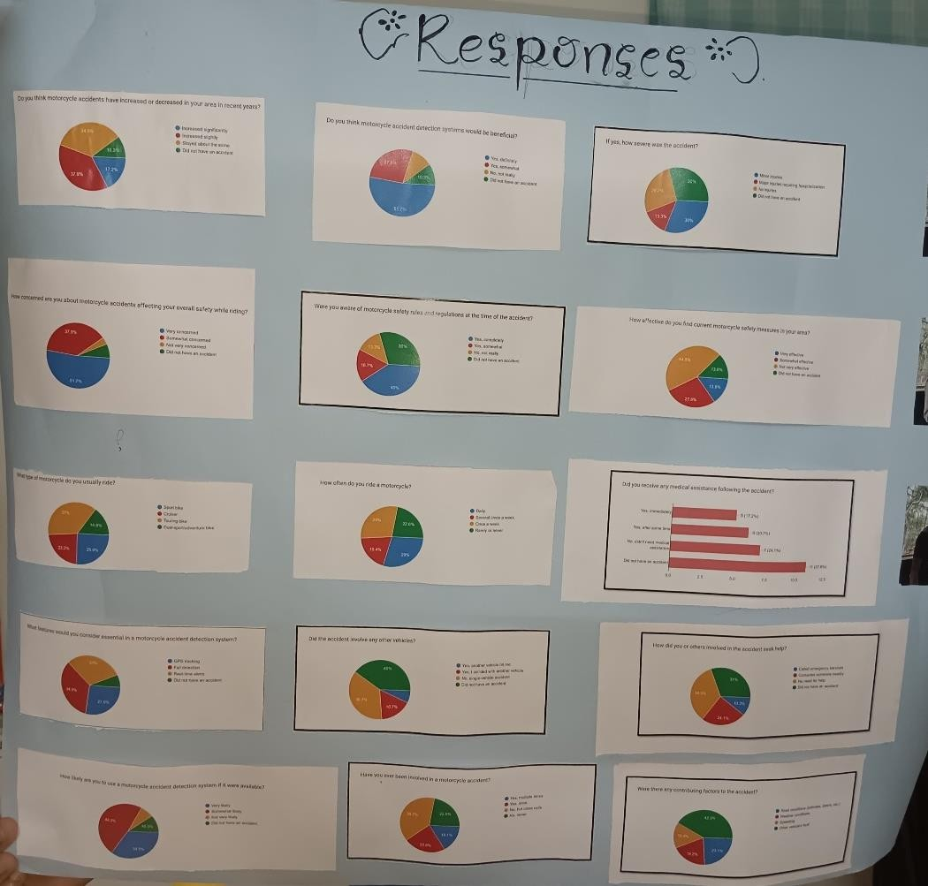

*Figure 30: Survey response*

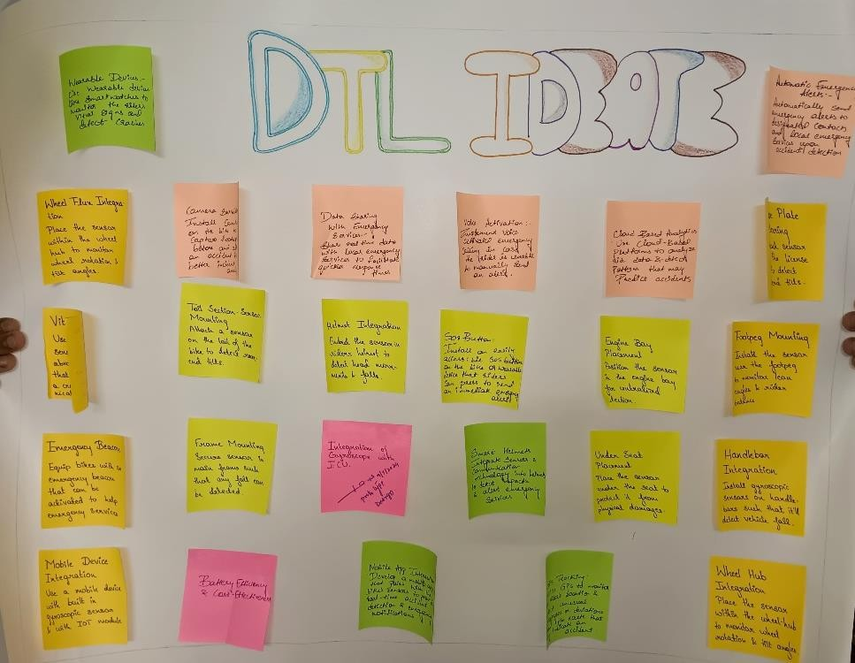

*Figure 31: Ideation*

After analysing the information collected from our survey, we created a diagram (*Figure 30 and Figure 31*) to illustrate the connections between various elements, such as the target groups, the specific challenges each group faces, potential solutions to these challenges, and the key insights we gained from our survey and research.

#### DEFINE

In this phase, we focused on evaluating, interpreting, and prioritizing the findings we gathered from our research and surveys. The insights derived from this process played a crucial role in shaping our final solution. After conducting observations and gathering survey responses, we concentrated on a selected group of individuals, summarizing their challenges and needs into a well-defined problem statement. Understanding how people are currently addressing bike accidents and alerting emergency services provided valuable insights into how we could innovate. Additionally, our solution needed to be easily scalable and seamlessly integrate into the user's daily life without causing disruption.

We have decided that our target will be “To provide a scalable, reliable, and efficient system for detecting bike accidents and promptly alerting emergency contacts and services to enhance rider safety.”

To achieve this goal, we plan to develop a smart, sensor-based system that detects accidents and sends real-time alerts through various communication channels. In our initial research, we explored a variety of potential solutions, many of which do not even require complex hardware to function effectively. By focusing on a streamlined and user-friendly design, we aim to create a system that not only improves safety but also fits effortlessly into the rider's routine.

#### IDEATION

The challenge of preventing and mitigating motorcycle accidents has persisted for decades. Our goal is to develop a sustainable and innovative solution that seamlessly integrates into the lives of motorcyclists without disrupting their riding experience. This system should effectively detect accidents, provide timely alerts, and contribute to reducing the number of motorcycle- related injuries and fatalities.

* + - **Real-time Accident Detection:** Utilize the ADXL345 accelerometer to detect sudden changes in acceleration and vibration, indicating a potential accident.
    - **GPS Location Tracking:** Employ the GPS NEO-6M module to accurately determine the motorcycle's location in case of an accident.
    - **Emergency Alert System:** Utilize the GSM 800L V2 module to send SOS messages or make emergency calls to designated contacts.
    - **Battery-Powered Design:** Implement a low-power design using a rechargeable lithium battery to ensure portability and extended usage.
    - **Cost-Effective Components:** Select affordable components to keep the overall cost of the system low.
    - **Compact and Lightweight Design:** Design the system to be small and lightweight for easy installation and minimal interference with the motorcycle.
    - **User-Friendly Interface:** Incorporate a simple and intuitive user interface, such as LED indicators or a small display, to provide feedback on the system's status.
    - **Customization Options:** Allow for customization of the accident detection threshold, emergency contact numbers, and other settings to suit individual preferences.
    - **Data Logging:** Implement data logging capabilities to record accident data, such as time, location, and sensor readings, for analysis and improvement.
    - **Integration with Smartphone Apps:** Develop a companion smartphone app to provide additional features, such as live tracking, remote configuration, and accident history.
    - **Cloud-Based Data Storage:** Store accident data on a cloud-based platform for remote access, analysis, and sharing.
    - **Integration with Emergency Services:** Explore partnerships with local emergency services to streamline the response process and improve efficiency.
    - **Social Media Integration:** Integrate with social media platforms to raise awareness about the system and share accident information with the community.
    - **Community Building:** Foster a community of users to share experiences, provide feedback, and contribute to the system's development.
    - **Educational Campaigns:** Conduct educational campaigns to inform riders about the benefits of using the system and promote safety awareness.
    - **Partnerships with Motorcycle Manufacturers:** Collaborate with motorcycle manufacturers to integrate the system into new models or offer it as an aftermarket accessory.
    - **Government Partnerships:** Explore partnerships with government agencies to promote the use of the system and support its development.
    - **Continuous Improvement:** Implement a feedback loop to gather user feedback and make ongoing improvements to the system's functionality and performance.
    - **Scalability:** Design the system to be scalable, allowing for easy expansion and adaptation to meet growing demand.
    - **Ethical Considerations:** Address ethical concerns related to data privacy, security, and
    - the potential impact of the system on rider behaviour.
    - **Sustainability:** Consider the environmental impact of the system and explore opportunities for sustainable manufacturing and materials.

#### PROTOTYPE

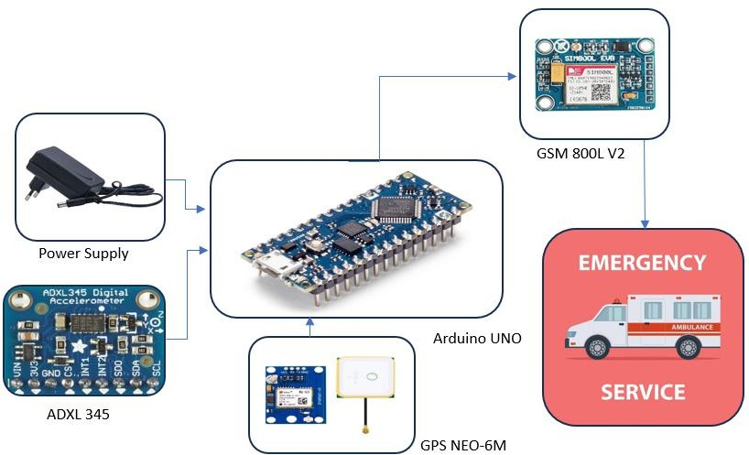

*Figure 32 Block Diagram*

The device’s fundamental structure is as shown in *Figure 32*. It represents the components used and the

implementation of the circuitry. The whole unit consists of 3 elements i.e.,

1. Input/Sensing element
2. Processing element
3. Output element

#### COMPONENTS

**ADLX 345**

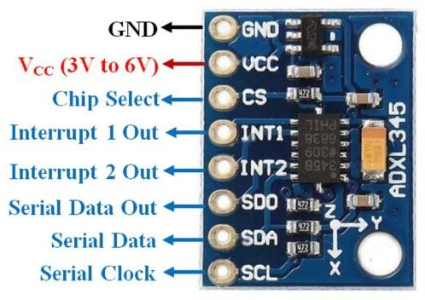

*Figure 33 ADXL 345*

The ADXL345 outputs 16-bit two's complement values representing the acceleration along the X, Y, and Z axes. These values are typically measured in g's (the acceleration due to gravity). The output data rate (ODR) can be configured from 0.1 Hz to 3200 Hz, allowing for different levels of sensitivity and power consumption. *Figure 33* shows the pin structure of ADXL 345.

##### Working

1. Acceleration Measurement: The ADXL345 uses a capacitive sensing element to measure the acceleration along each axis. This element consists of two parallel plates that move relative to each other when the device is subjected to acceleration. The change in capacitance is then converted into an electrical signal.
2. Analog-to-Digital Conversion: The analog signal from the sensing element is converted into a digital value using an on-chip analog-to-digital converter (ADC).
3. Data Output: The digital output data is formatted as 16-bit two's complement values and is accessible through either an SPI (3- or 4-wire) or I2C digital interface.

##### Key Features

* + High Resolution: The ADXL345 offers a high resolution of 13 bits, allowing for precise measurements of acceleration.
  + Low Power Consumption: The device has a low power consumption, making it suitable for battery-powered applications.
  + Wide Measurement Range: The ADXL345 can measure acceleration up to ±16 g, making it suitable for a wide range of applications.
  + Configurable Output Data Rate: The ODR can be adjusted to balance sensitivity and power consumption.
  + Special Sensing Functions: The ADXL345 includes features such as tap detection, activity/inactivity monitoring, and free-fall detection.

#### GSM 800L V2

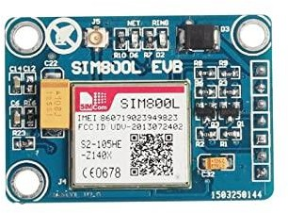

*Figure 34 GS 800L V2*

The GSM 800L V2 (*Figure 34)* is a quad-band GSM/GPRS module that provides wireless communication capabilities, including voice calls and SMS messaging. It is widely used in various applications, such as IoT devices, home automation systems, and wearable technology.

##### Key Features:

* + **Quad-band support:** Works on 850/900/1800/1900 MHz frequencies, ensuring global compatibility.
  + **GSM/GPRS capabilities:** Supports both voice calls and data transmission over the GPRS network.
  + **AT commands:** Controlled using AT commands, a standardized communication protocol for GSM modules.
  + **Power supply:** Operates on 3.3-4.5V DC.
  + **Small form factor:** Suitable for embedded applications.
  + **TTL serial interface:** Compatible with microcontrollers and other devices.

##### Considerations:

* + **SIM card:** Requires a GSM SIM card to function.
  + **Antenna:** Requires an external antenna for optimal performance.
  + **Power consumption:** Consider power consumption when designing systems that use this module.
  + **Regulatory compliance:** Ensure compliance with local regulations regarding GSM usage.

#### GPS NEO-6M

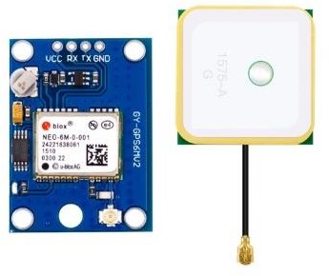

*Figure 35 GPS NEO 6M*

The GPS NEO-6M is a low-cost GPS receiver module that provides accurate positioning and time information. It comes with its own antenna refer *Figure 35*. It is widely used in various applications, including GPS navigation systems, tracking devices, and IoT projects.

##### Key Features:

* + **Low-cost:** Affordable and suitable for budget-constrained projects.
  + **High sensitivity:** Can acquire signals in challenging environments, such as indoors or urban areas.
  + **Low power consumption:** Ideal for battery-powered applications.
  + **Small form factor:** Compact size for easy integration into various devices.
  + **Serial communication:** Interfaces with microcontrollers using a serial communication protocol (typically UART).
  + **NMEA output:** Provides GPS data in NMEA format, which is widely supported by software applications.
  + **10 Hz update rate:** Can provide position updates at a frequency of 10 times per second.

##### Considerations:

* + **External antenna:** Requires an external antenna for optimal performance.
  + **Clear sky view:** Best performance is achieved with a clear view of the sky.
  + **Power supply:** Ensure adequate power supply for reliable operation.
  + **Software support:** Utilize appropriate software libraries or tools to process GPS data.

##### Arduino Nano

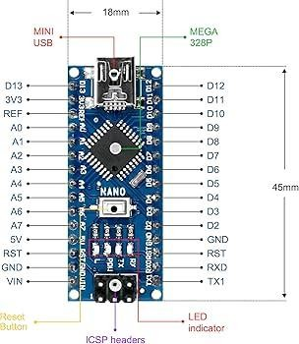

*Figure 36 Arduino Nano*

The Arduino Uno is a popular microcontroller board used for various projects, including electronics, robotics, and automation. It is based on the ATmega328P microcontroller and

provides a simple and accessible platform for beginners and experienced users alike. *Figure 36*

shows the pinout of Arduino nano.

##### Key Features:

* + **Microcontroller:** ATmega328P (8-bit AVR)
  + **Clock Speed:** 16 MHz
  + **Memory:** 32 KB flash memory, 2 KB SRAM, 1 KB EEPROM
  + **Input/Output Pins:** 14 digital I/O pins (6 PWM outputs), 6 analog inputs
  + **Power Supply:** 5V DC (USB or external power supply)
  + **On-board LEDs:** Power LED, TX LED, RX LED
  + **Reset Button:** For manually resetting the microcontroller
  + **ICSP Header:** For programming the microcontroller using an external programmer

#### WORKING OF THE MODEL

The motorcycle accident detection system uses an Arduino Nano as the central controller, connected to an ADXL345 accelerometer, a GPS NEO-6M module, and a GSM 800L module. The ADXL345 is a 3-axis accelerometer that continuously monitors the motorcycle’s acceleration and orientation. When the motorcycle experiences a sudden change in acceleration or tilts beyond a certain threshold, the system detects it as a potential accident. This data is then processed by the Arduino Nano, which applies specific algorithms to differentiate between regular bumps or minor jerks and severe accidents. By monitoring the intensity and duration of these changes, the system can accurately detect when a crash has occurred.

Once an accident is detected, the Arduino Nano communicates with the GPS NEO-6M module to retrieve the real-time location of the motorcycle. The GPS module provides accurate latitude and longitude coordinates, which help identify the exact location of the accident. This data is crucial for directing emergency responders to the scene of the crash, reducing the response time, and potentially saving lives. After retrieving the location, the Arduino Nano sends a message through the GSM 800L module. The GSM module sends an SMS alert to predefined emergency contacts, including the location coordinates and accident information, ensuring that the rider’s family or emergency services are notified immediately.

By utilizing these components and algorithms, the motorcycle accident detection system provides a vital safety feature for motorcyclists, enabling faster responses in the event of a crash and contributing to post-accident analysis.

#### MODEL OF BIKE ACCIDENT DETECTION AND ALERTING DEVICE

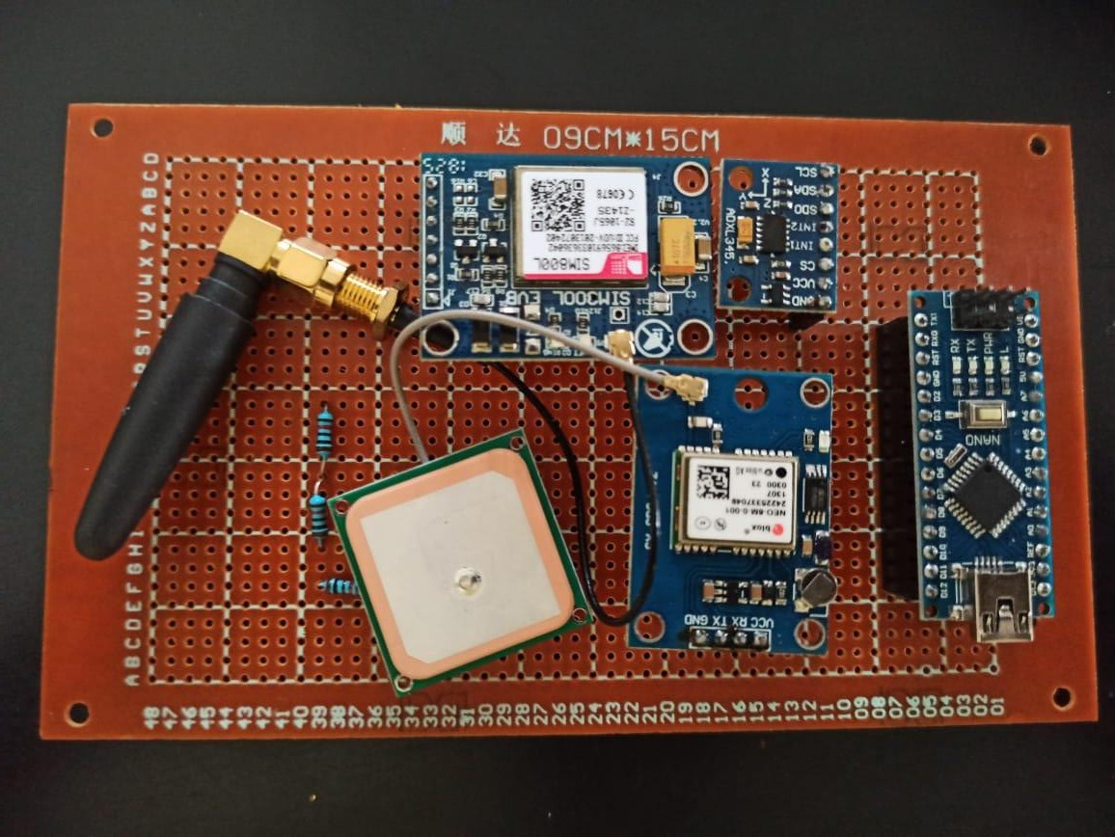

*Figure 37 Prototype*

The bike accident detection and emergency response system, built around an Arduino Nano, ADXL345, GSM 800L, and GPS modules soldered onto a PCB, offers a robust and compact solution for enhancing rider safety. *Figure 37* is the prototype of our motor cycle accident detection and response system. The PCB ensures secure connections and a streamlined design, while the sensitive accelerometer, precise GPS, and reliable GSM module work together to provide real-time emergency alerts in case of an accident. This system, depicted in Figure 1, utilizes a combination of hardware and software to provide real-time emergency alerts. By incorporating this technology into motorcycles, riders can significantly enhance their safety and peace of mind, knowing that immediate assistance is readily available in the event of an accident.

This system is designed to be power efficient, relying on the motorcycle’s battery. However, to ensure reliability, a small backup battery can be integrated to maintain the functionality of the modules in case of power loss during an accident. Additionally, the system can be expanded with features like an SOS button for the rider to manually trigger an alert in other emergency situations.

#### COST ESTIMATION

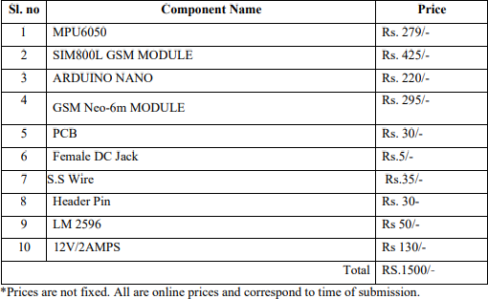

* 1. **CONCLUSION**

This project successfully demonstrates the feasibility of developing a low-cost motorcycle accident detection and alerting system using Arduino Nano, ADXL345, GSM 800L V2, and GPS NEO-6M modules. The system effectively detects accidents based on changes in acceleration, acquires accurate location data, and sends timely emergency alerts.

The integration of these components into a compact and portable device provides a valuable safety solution for motorcyclists. The system's ability to operate independently without requiring external intervention ensures timely assistance in emergency situations.

Future enhancements could include exploring advanced machine learning algorithms for more accurate accident detection, integrating with smart helmet technology for additional safety features, and expanding the system's capabilities to provide real-time traffic updates and navigation assistance.

Overall, this project contributes to the development of innovative technologies that can improve road safety and save lives.

# DESIGN THINKING LAB (EI247DL)



## WEEKLY PROGRESS REPORT

|  |  |
| --- | --- |
| **WEEK** | **STATUS** |
| Week - 1 & 2 | Design thinking process breakdown |
| Week - 3 & 4 | Empathy phase: Conducted survey through google form questionnaire and public interviews and analysed it.  Define phase: Identified problem statement adhering to the pain, need, gain and target groups. |
| Week - 5 | Ideation phase: Brainstorming ideas and solutions, looking into various techniques and aspects to go about our design process. |
| Week- 6&7 | We made the Block diagram, circuit diagram and bought the components looked for cloud services and compiled the code |
| Week -8,9&10 | Prototyping Phase: We optimised the code and the best location to place the setup inside while also carefully bettering the equipment that we were using and substituting it for better equipment |
| Week – 11 | Final Presentation, recording of data and error detection |
| Week – 12&13 | Submission of Reports & Poster. |

**MINI REPORT**

**MINI REPORT**

## SUMMARY REPORT ON DESIGN THINKING LAB

**TEAM RAKSHAK** - Chandana (1RV22EI014), Medha K S (1RV22EI032), Shubham RK (1RV20EI054), Varun S (1RV22EI060)

**THEME -** Design thinking in Energy

**TITLE** - Bike Accident Detection & Alerting Device

### INTRODUCTION:

Design thinking is a structured approach that involves collaborative workshops and individual efforts to address complex problems. It begins with understanding people's challenges and desires, placing them at the forefront of the solution process. This method is particularly effective in creating solutions within social contexts, whether through a product, service, or conceptual approach. The problem of bike accidents, with their potential for severe consequences and frequent occurrences, has remained a critical issue. Effective solutions must not only detect accidents reliably but also provide timely alerts to ensure quick assistance. Our project aims to develop a comprehensive bike accident detection and alerting device, utilizing design thinking to create an innovative and practical solution.

### PROBLEM IDENTIFIED:

The team members of Project RAKSHAK have experienced firsthand the dangers of bike accidents, particularly in areas with heavy traffic and unpredictable road conditions. The frequent occurrence of bike accidents results in significant injuries and fatalities, exacerbated by delayed emergency responses. Current systems often lack the ability to accurately detect accidents and notify emergency services promptly. Our goal is to address this gap by developing a device that can reliably detect accidents, differentiate between routine maneuvers and genuine incidents, and send real-time alerts to emergency contacts. By implementing such a system, we aim to enhance rider safety, reduce response times, and ultimately save lives. The project addresses critical issues such as accident detection accuracy, timely communication,

and the overall effectiveness of emergency response, contributing to improved safety for cyclists and motorcyclists alike.

### PROPOSED SOLUTION:

The proposed bike accident detection and alerting device integrates an accelerometer, gyroscope, GPS module, and GSM module to offer a comprehensive safety solution. This system is designed to detect accidents in real-time, notify emergency contacts, and provide precise location data.

The accelerometer and gyroscope work together to monitor the bike's movement and orientation. The accelerometer measures acceleration forces, while the gyroscope tracks rotational movement. By analyzing data from these sensors, the device can detect sudden impacts or unusual tilts indicative of an accident. If an accident is detected, the system activates the alert mechanism.

The GPS module plays a crucial role by providing the precise location of the incident. It continuously updates the device’s coordinates, allowing for accurate tracking and emergency response. When an accident is detected, the GPS data is used to determine the bike's location.

The GSM module is responsible for communication. It sends out real-time alerts to pre-set emergency contacts, including details of the accident and the bike’s GPS location. This ensures that help can be dispatched quickly. *Figure 1* gives us the prototype.



*Figure 1 Prototype*

The block diagram and working model of the system illustrate how the sensors and modules are interconnected, with data being processed by the microcontroller. The GSM module handles communication, while the GPS module provides location information. This setup ensures effective accident detection and timely alerting, enhancing rider safety and facilitating swift assistance.

### WORKING OF MODEL

The Bike Accident Detection and Alerting Device is equipped with an accelerometer, gyroscope, GPS module, and GSM module. Together, these components work to detect accidents accurately and provide immediate alerts:

The accelerometer measures the acceleration forces acting on the bike, detecting any sudden changes in speed or direction that could indicate an accident. The gyroscope monitors the rotational movement of the bike, capturing data on its orientation and tilt. By analyzing the data from both sensors, the system can identify abnormal patterns, such as sudden impacts or unusual tilts, which are strong indicators of an accident. This dual-sensor approach enhances the accuracy of accident detection by minimizing false alarms caused by regular riding maneuvers.

Upon detecting an accident, the device triggers an alert mechanism. This mechanism can be customized to notify emergency contacts, including family members or emergency services, about the incident. The alert is initiated through the GSM module, which sends an automated SMS containing critical information about the accident.

The GPS module is integral to the system as it provides real-time location data of the motorcycle. This module continuously updates the device's coordinates to ensure accurate tracking. In the event of an accident, the GPS module’s data is used to determine the bike's exact location, which is then included in the alert sent to emergency contacts. This feature is crucial for enabling a swift emergency response, particularly in remote areas where immediate medical assistance may be challenging.

The integration of accelerometer and gyroscope sensors allows for immediate identification of accidents, significantly reducing the time taken to recognize and respond to an emergency. The

GPS module provides precise location information, ensuring that emergency responders can quickly locate the accident site.



The GSM module automates the process of sending alerts, reducing the need for rider intervention and ensuring that help is notified promptly, even if the rider is unconscious or unable to make a call. By combining multiple sensors and communication modules, the device offers a robust solution for enhancing rider safety and improving emergency response times.

### CONCLUSION

The Bike Accident Detection and Alerting Device represents a significant advancement in motorcycle safety technology. By leveraging accelerometers, gyroscopes, GPS, and GSM modules, the device provides a comprehensive solution for accident detection and emergency notification. This innovative approach not only enhances rider safety but also has the potential to reduce the impact of accidents through quicker emergency response, ultimately saving lives and reducing the severity of injuries.

This device could be a valuable tool for motorcyclists, promoting a safer riding experience and peace of mind on the road.